**Prototype running example figures:**

**Landing page of application :**

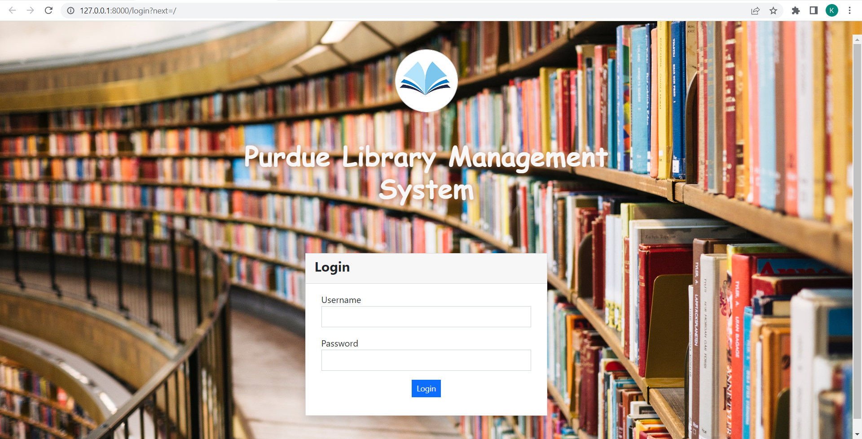

**Administrators Dashboard :**

Admin can view and add new users to the application.

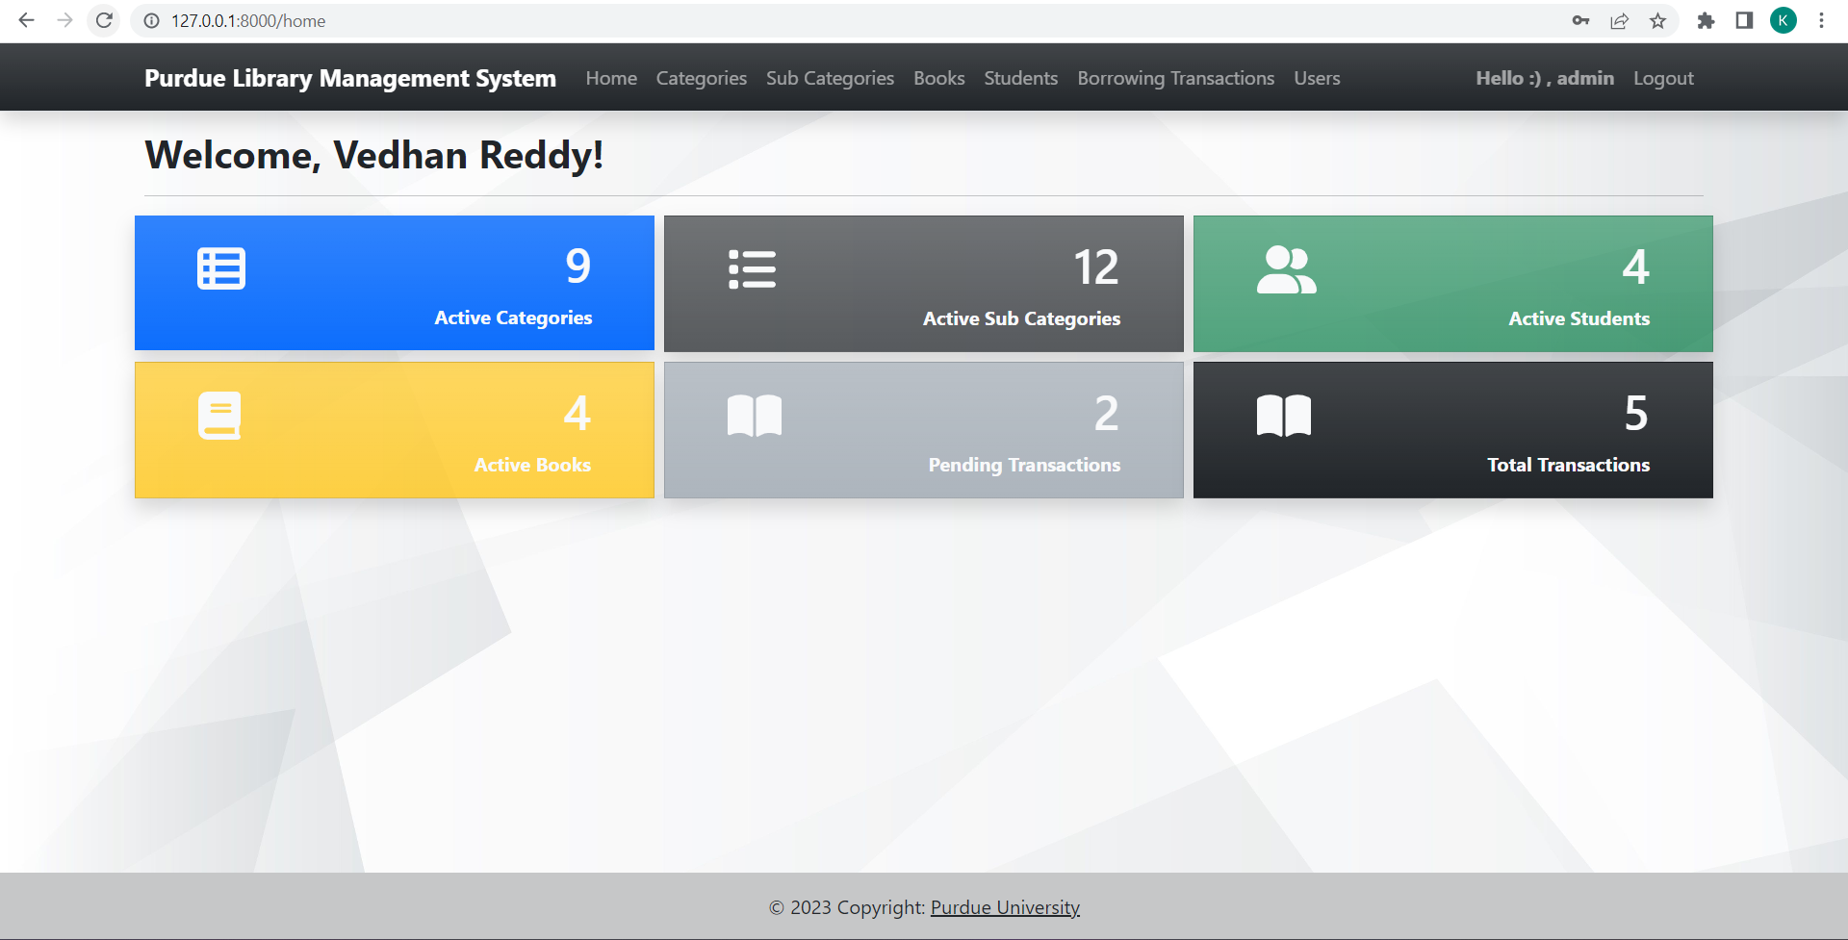

Data warehousing is a process of collecting, managing, and storing large amounts of data from various sources and organizing it in a way that enables efficient querying and analysis. The purpose of data warehousing is to provide a centralized repository of data that can be used for decision-making and reporting purposes.

In our project, we are collecting and storing various data points such as transaction details, student information, and book availability information, and organizing it in a way that allows for efficient querying and analysis. **The dashboard that displays the analytical reports is an example of how this organized data can be used for decision-making and reporting purposes**.

**Other users dashboard :**

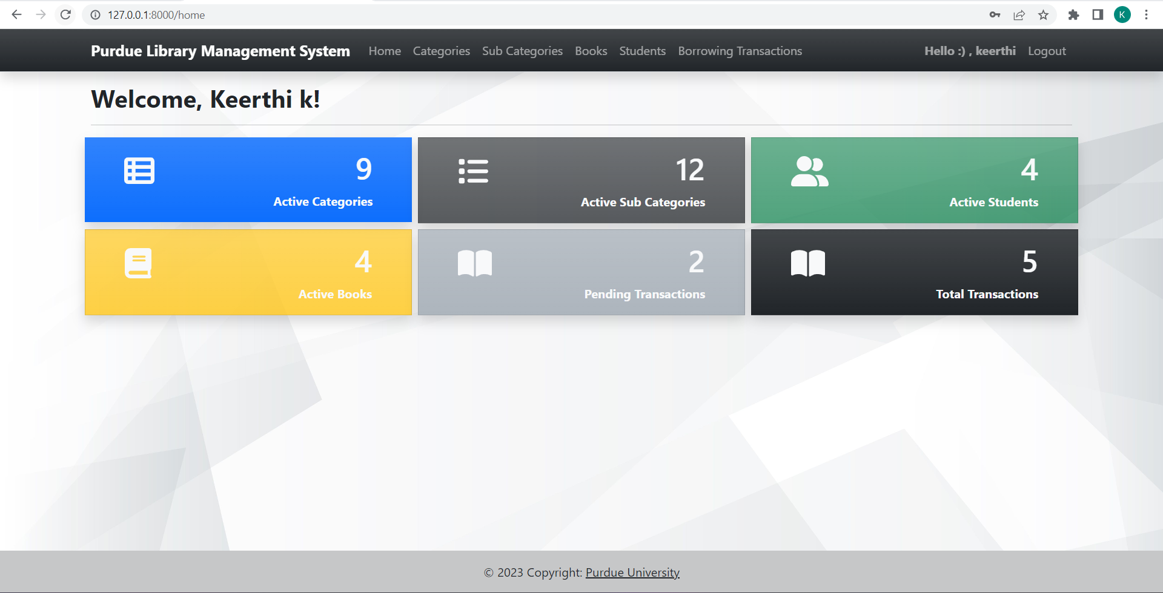

**List of all categories of books that the library is keeping :**

Active status indicates that particular category is available in the library.

**Adding new category to the library :**

**List of Subcategories for the category that the library is keeping :**

**Description :** Computer science category has different subcategories like Data Science, Database Concepts, Operating Systems, Programming books as shown in the above image. Users can add new subcategory only for the active categories.

**Adding new subcategory to the library:**

**List of books shows all the books that the library is keeping:**

**Adding new book to the library :**

ISBN is a unique number that the library will assign to identify a particular book.

Search Functionality :

User can search for the particular book from all the available books.

Action drop-down functionality :

User can view, edit, or delete the book details by clicking on the Action dropdown button.

**List of students registered with the library :**

**Registering new student with the library :**

**List of Borrowing transactions displays all the book borrowing transactions :**

Books that are returned can be marked as **Returned**.

**Book borrowing transaction functionality :**

**Description :** The status field in the new transaction by default is set to Pending as the student is borrowing the book from the library.

User Profile screen:

Update Password functionality :

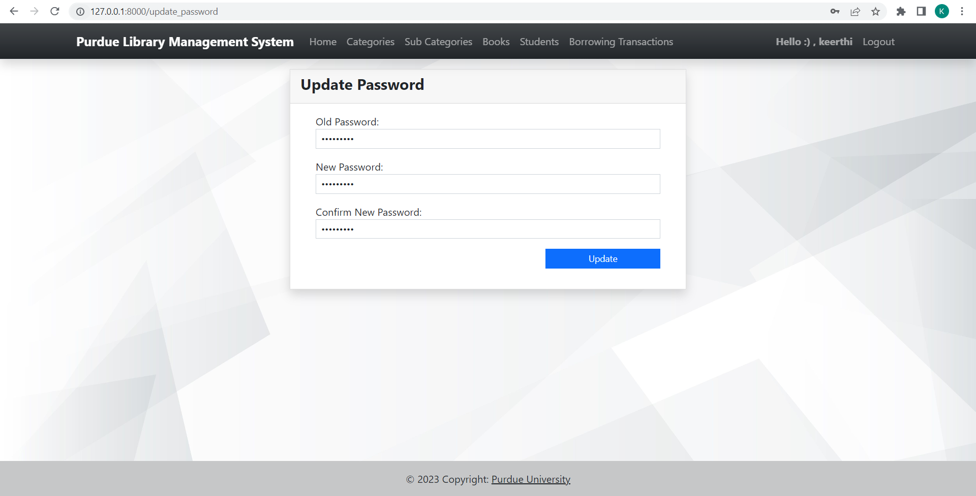

**Description :** User can update the password by entering his old password. Only if the old password is entered correctly, user will be able to update the password. System will throw an error if the old password is incorrect while updating the password.

User authentication and security :

Update profile screen :

**Description:** User must enter his password to update his profile information. Only if the password is correct, User can update his profile information. System will throw an error message if the password entered is incorrect.

**User authentication and security :**

